**Guided Notes**  **Name:**



***Visit inquiryresearchplatform.weebly.com. All videos on this handout are under the “Searching for Information” tab.***

1. Watch the video linked to the button, **“Boolean Operators”** to fill in the following mindmap. To find the Venn Diagrams, complete the Interactivity, **“The Boolean Machine”.**
2. Watch YouTube videos linked to the page **“Advanced Searching”** to find the answers to the following questions*. (Hot tip! Answers appear in chronological order.)*
   1. ***Video: Narrowing Down Your Search***
      1. Describe what search engines do when you type a word into the search bar?
      2. What would happen to your search results if your keyword search is not specific enough?

For example, what would happen if you typed in the word “fish” into the search bar on Google?

* + 1. How could you narrow down your results if your original search provides too many websites?
    2. What are some basic “shortcuts” to help you narrow down your search results? Provide an example of each shortcut.

(2)

* 1. **Video: Searching in Action**
* Get ready to pause so you can write each tip down! If you can, give an example of each.
  + - 1. How to search an exact phrase or quote:
      2. How to exclude a word from search results:
      3. How to search within a single website:
      4. How to limit your search to the most current websites
      5. How to find images that are free to use on your own site
      6. How to search phrases/quotes with missing words:

1. Watch YouTube videos linked to the page “**Researching Beyond Google: Databases!”** to find the answers to the following questions*.*
2. **Video: What are databases?**
   1. What do databases allow us to find on the web?
   2. Where do databases get their information from?
   3. List the four advantages to using databases that are outlined at the end of the video.
      * ______________________________
      * ______________________________
      * ______________________________
      * ______________________________
3. **Video: How to search in a database**
   1. Where should you search if you want to find journal articles?
   2. In the blanks, label the “search bar”, and what each Boolean operator will do.

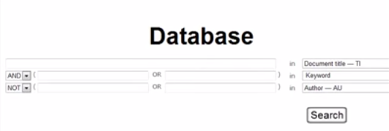



* 1. Draw the Venn diagram that uses the search: history AND Canada NOT Burton.

1. Watch YouTube videos linked to the page “**Types of Sources”** to fill in these notes.
   1. **Video: Understanding Primary & Secondary Sources**
      1. As you watch the video write notes on the differences between each type of source. Include examples of and the advantages of each.

|  |  |
| --- | --- |
| **Primary Sources** | **Secondary Sources** |
|  |  |

* + 1. Name two sources that can be both a primary source and a secondary source.
       1. ___________________________
       2. ___________________________
  1. **Video: Finding Scholarly Material**
     1. Before watching the video, type the following into a

Google Search Bar: **define: "scholarly source"**

In your own words, summarize what a scholarly source is.

* + 1. What is an advantage of using Google Scholar?
    2. What are two disadvantages of using Google Scholar?
    3. Instead of using Google Scholar, what is a better way to access scholarly material?